Mr Robot CTF_Solution_Documentation
Written by: Yuval Quina
I started this CTF by performing a scan of open ports and services on the target side using Nmap:
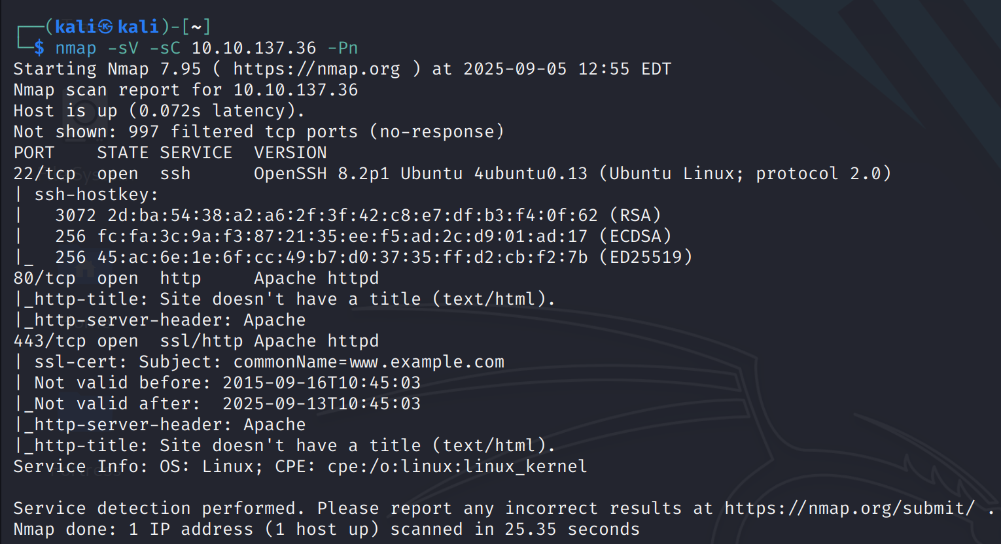
I discovered 3 open ports: 80 & 443 (which are assigned to http and https) and 22 (of ssh).
I opened the website of the target using port 80 which loaded in front of me an animation of a terminal process that runs and waits for my input:
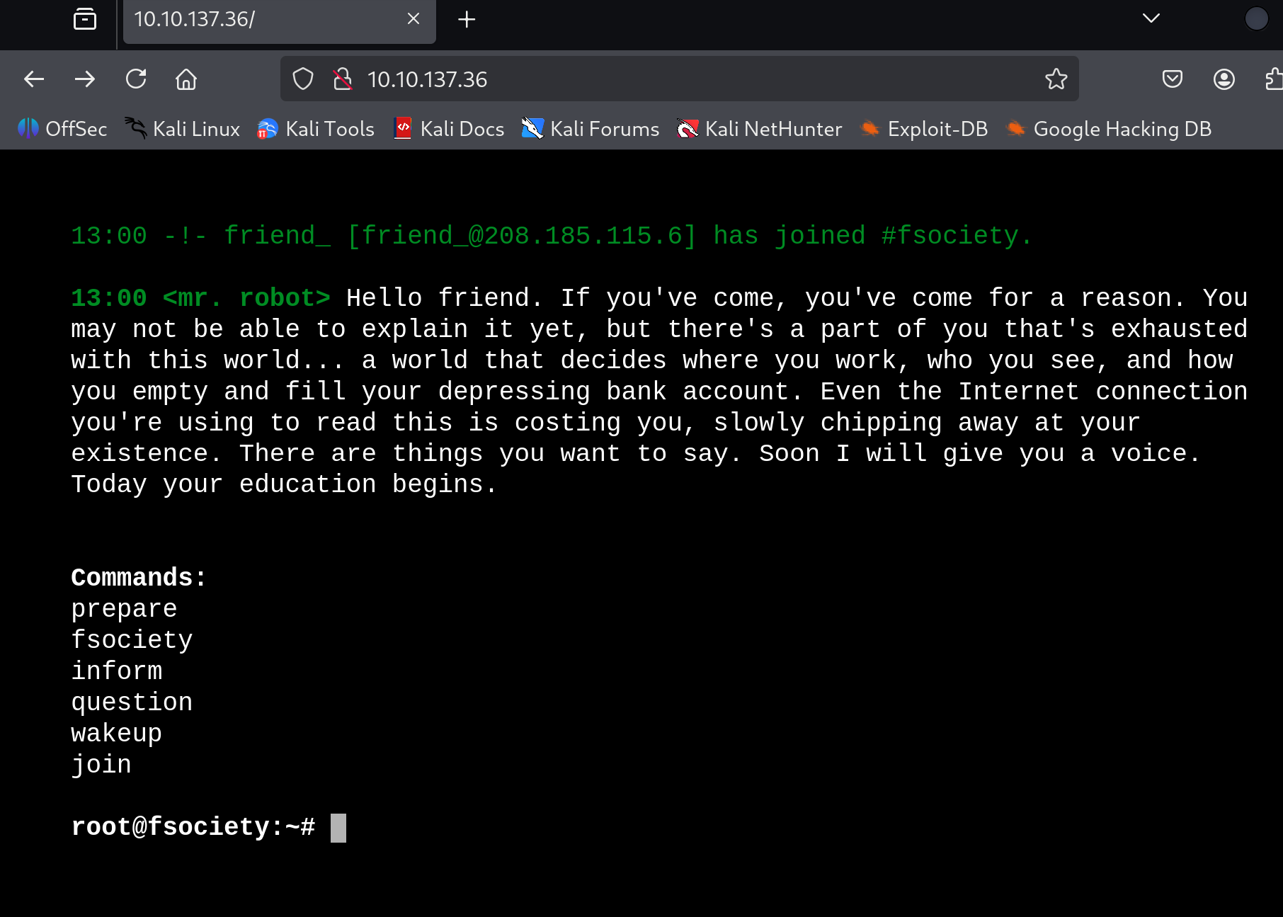
I read the text and

